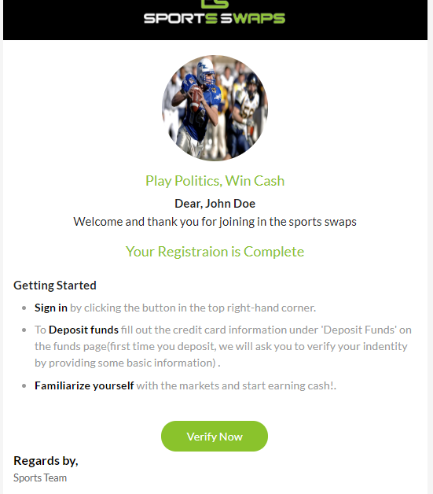

Change image to sportsswaps logo

Trade Sports, Win Cash

Dear, (Username)

Welcome and thank you for joining SportsSwaps!(link sportsswaps to our website)

Your Registration is Complete

Getting Started

* Sign in by clicking the button in the top right hand corner
* To Deposit Funds choose the cryptocurrency of your liking from our various selection of cryptocurrency options
* Familiarize yourself with the markets and start earning cash!

Verify Now

Best Regards,

SportsSwaps